**Web Designing**

**MODULE: 1 (HTML)**

**Q1. Are the HTML tags and elements the same thing?**

**A1.** In HTML *(HyperText Markup Language)*, tags and elements are not the same thing there is a subtle difference between them.

HTML **Tags** are building blocks of HTML Page. They tell the browser how it should display content to the user. The tag is written within the angular brackets ‘<tagname>’. Most tags exist in pairs in HTML. Tags have opening and closing parts.

*Opening tag*: <tagname> *Closing tag*: </tagname>

HTML **Elements** are components of web page that are used in HTML Page. It includes a start tag, content and an end tag. You can also have attributes in your tags such as ‘class’ & ’id’.

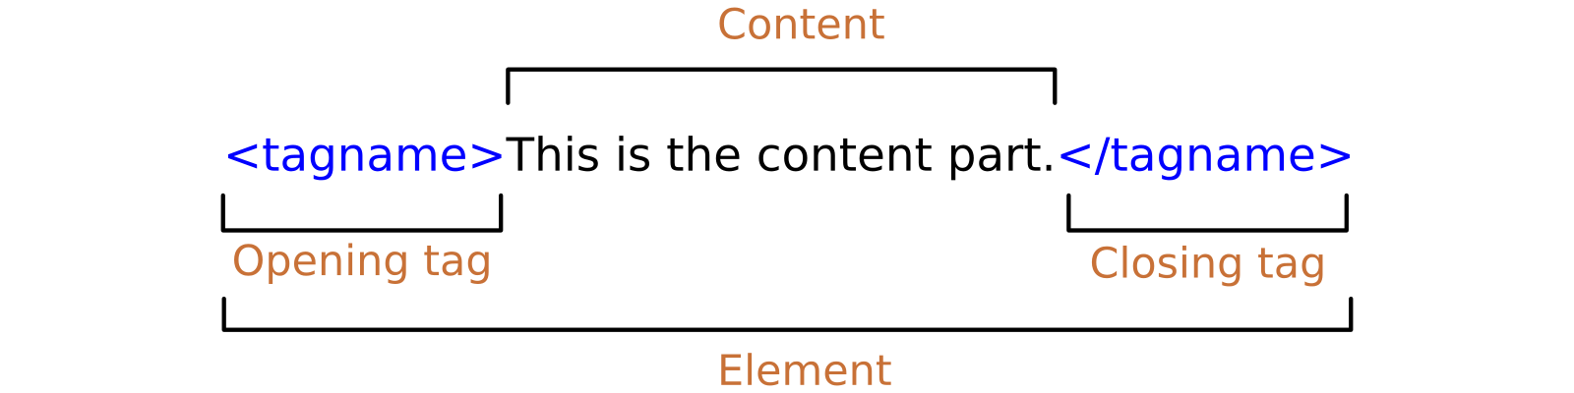

**Q2. What are tags and attributes in HTML?**

**A2.** In HTML, tags and attributes are fundamental components used to structure and define web documents. They play an essential role in specifying the structure and appearance of content within a webpage.

HTML **Tags** are building blocks of HTML Page. They tell the browser how it should display content to the user. They are used to enclose and define different parts of content within an HTML document. HTML tags are enclosed within angular brackets eg. **<**tagname**>**.

Common HTML tags include **<html>**, **<head>**, **<body>**, **<h1>**, **<p>**, **<img>**, etc.

HTML **Attributes** provide additional information about an HTML element. Attributes are always specified within the opening tag of an element and are followed by an equal sign ’=’ and a value enclosed within a quotation marks. They modify the bhehaviour or appearance of an HTML element. Attributes are key-value pairs that provide context and configuration for elements.

Common HTML attributes include **style**, **height**, **width**, **href**, **src**, etc

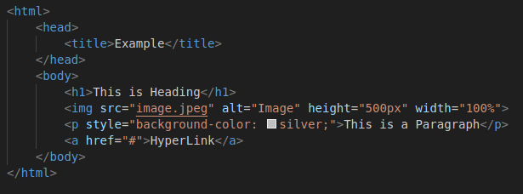

In the above example, the tags are **html, head, title, body, h1, img, p, a** while **src, alt, height, width, style, href** are attributes.

**Q3. What are void elements in HTML?**

**A3.** Special group of elements that only have start tags and does not contain any content within it are called **void elements**. Void elements doesn’t have ending tags and can only have attributes but do not contain any kind of content. Examples of such elements are **<br>**, **<hr>**, **<img>**, **<input>**, **<link>**, **<meta>**, **<source>** etc.

Characteristics of void elements:

* They do not have end tags.
* They cannot have content inside it.
* They have attributes.
* They cannot be nested.

The following are some of the void elements:

1. **<br>**: Represents a line brake.
2. **<hr>**: Represents a thematic brake or horizontal rule.
3. **<img>**: Used for embedding images.
4. **<input>**: Used for creating input fields in forms.
5. **<link>**: Used to link external stylesheets.
6. **<meta>**: Contains metadata about the document
7. **<source>**: Used to provide the path of the file.

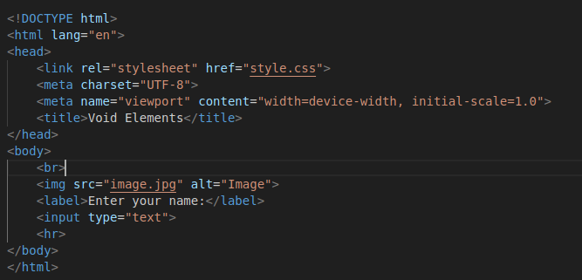

**Q4. What are HTML Entities?**

**A4.** HTML **entities** are special codes or character references used to represent characters that have special meanings in HTML, or characters that cannot be easily typed or displayed using the standard keyboard or character encoding. HTML entities are especially useful when you need to display reserved characters, symbols, or characters with special purposes within your HTML document.

HTML entities are represented by an ampersand (&), followed by a specific code or name, and ending with a semicolon (;).

**Syntax**: &entity_name; *OR* &#entity_number;

| **Character** | **Entity** |
| --- | --- |
| ≥ | &GreaterEqual; |
| © | &copy; |
| € | &euro; |
| ∃ | &exist; |

| **Reserved Character** | **Entity Name** |
| --- | --- |
| & | &amp; |
| < | &lt; |
| > | &gt; |
| “ | &quot; |

Few other entities are:

* **&apos;** *or* **&rsquo;** - (‘)
* **&reg;** - (®)
* **&trade;** - (™)
* **&plusmn;** -(±)
* **&times;** - (×)
* **&divide;** - (÷)
* **&#128513;** - **😁** (Hexadecimal Representation)

**Q5. What are different types of lists in HTML?**

**A5.** HTML Lists allow web developers to group a set of related items in lists. There are 3 types of lists in HTML.

1. **Unordered List**

An unordered list starts with the **<ul>** tag. Each list item starts with the **<li>** tag. The list items will be marked with disc (*filled circle*) by default.

Types of Un-Ordered List:

* **Square**
* **Circle** (Unfilled Circle)
* **Disk** (Filled Circle)

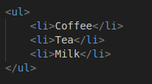

1. **Ordered List**

An ordered list starts with the **<ol>** tag. Each list item starts with the **<li>** tag. The list items will be marked with numbers by default.

Types of Ordered List:

* **1** (Numbers)
* **A** (Capital Alphabets)
* **a** (Small Alphabets)
* **I** (Capital Roman Numbers)
* **i** (Small Roman Numbers)

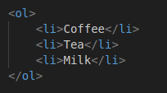

1. **Description List**

HTML also supports description lists. A description list, is a list of terms, with a description of each term. The **<dl>** tag defines the description list, the **<dt>** tag defines the term, and the **<dd>** tag describes each term.

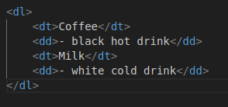

**Q6. What is the ‘class’ attribute in HTML?**

**A6.** The **class** attribute specifies one or more classnames for an HTML element. The class attribute is mostly used to point to a class in a style sheet.

The class attribute can be used on any any HTML element.

The class name can be used by CSS and JavaScript to perform certain tasks for elements with the specified class name.

In CSS, the class attribute is written using the “.” symbol followed by class name within the <style> tag.

**Syntax:** <element class=”class_name”>

In Css Stylesheet:

.class_name {

// CSS Property;

}

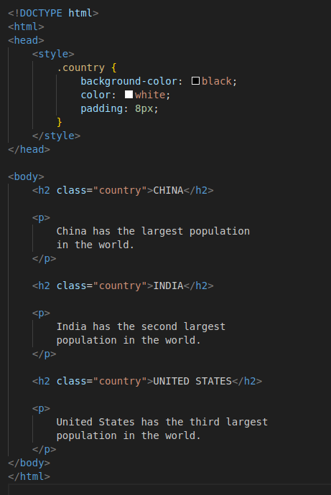

**Q7. What is the difference between the ‘id’ attribute and the ‘class’ attribute of HTML elements?**

**A7.** HTML **id** attribute is a unique identifier that is used to specify the document. It is used by CSS and JavaScript to perform a certain task for a unique element. In CSS, the id attribute is written using the “#” symbol followed by id.

**Syntax:** <element id=”id_name”>

In Css Stylesheet:

#id_name {

// CSS Property;

}

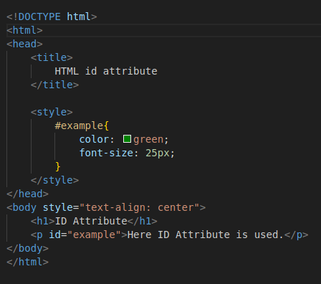

HTML **class** attribute is used to specify one or more class names for an HTML element. The class attribute can be used on any HTML element. It is used by CSS and JavaScript to perform certain tasks for elements with the specified class name. In CSS, the class attribute is written using the “.” symbol followed by class name.

**Syntax:** <element class=”class_name”>

In Css Stylesheet:

.class_name {

// CSS Property;

}

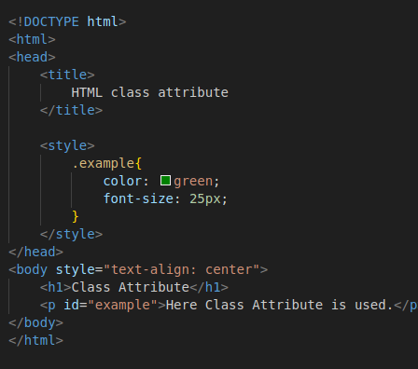

A **class** name can be used by multiple HTML elements, while an **ID** name must be used by one HTML element within the page.

**Q8. What are the various formatting tags in HTML?**

**A8.** In HTML, formatting tags are used to control the visual appearance and style of text and content on a webpage. Here are some common formatting tags in HTML.

1. **<b>** - This tag is used to make the text **BOLD**.



1. **<strong>** - This tag is used to indicate strong emphasis, typically rendered as **BOLD** text.



1. **<i>** - This tag is used to make the text *ITALIC*.



1. **<em>** - This tag is used to indicate emphasis, typically rendered as *ITALIC* text.



1. **<u>** -This tag is used to make the UNDERLINE text.



1. **<mark>** - This tag is used to highlight or MARK text.



1. **<sub>** - This tag is used to render text as **SUBSCRIPT**, typically for chemical formulas and mathematical expressions.



1. **<sup>** - This tag is used to render text as **SUPERSCRIPT**, typically for mathematical exponents.



1. **<ins>** - This tag is used tp indicate inserted or added text.



1. **<del>** - This tag is used to indicate deleted or removed text.



1. **<abbr>** - This tag is used for ABBREVIATIONS or acronyms, providing an optional title attribute for expanded forms.



1. **<blockquote>** - This tag is used to create BLOCK-LEVEL QUOTATIONS.

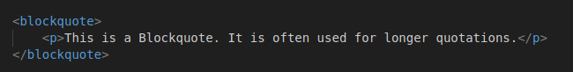

1. **<pre>** - This tag is used for text that should be displayed in a fixed-width font and preserve ehitespace and line breaks.

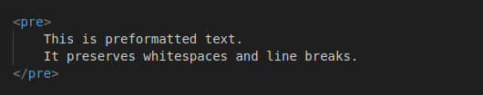

1. **<strike>** - This tag is used to add a line through the center of the tag ~~STRIKE~~.



**Q9. How is Cell Padding different from Cell Spacing?**

**A9.** Cell Padding and Cell Spacing are two different things.

**Cell Spacing** is a property of table that refers to the distance between the cells in a grid layout. By default the spacing is set to 2px.

**Cell Padding** is a property of table that refers to the space around each cell. By default the padding is set to 0.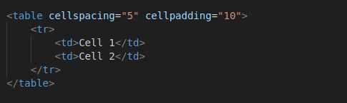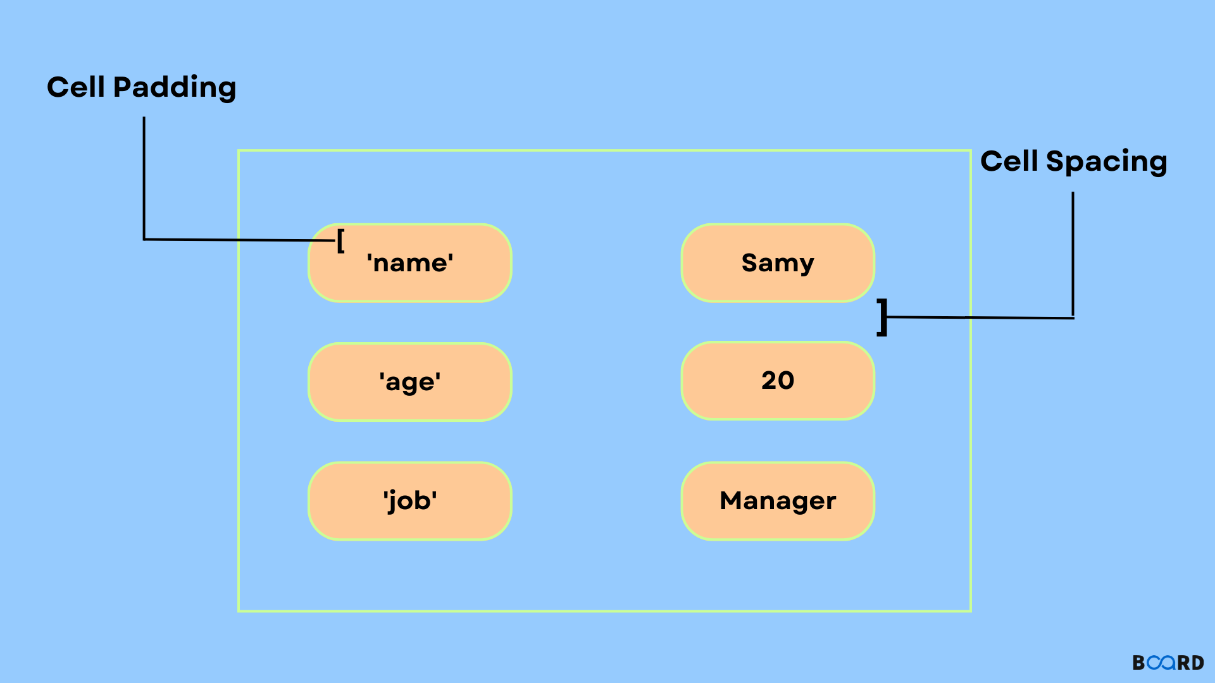

**Q10. How can we club two or more rows or columns into a single row or column in an HTML table?**

**A10.** In HTML tables, you can merge two or more rows into a single row or two or more columns into a single column using the rowspan and colspan attributes respectively. These attributes allow you to create cells that span across multiple rows or columns.

To merge multiple rows in a single row, **rowspan** attribute is used on a **<td>** element.

To merge multiple columns in a single column, **colspan** attribute is used on a **<td>** element.

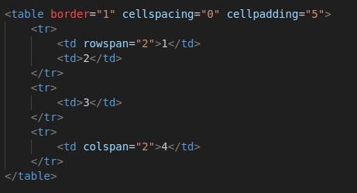

**Q11. What is the difference between a block-level element and an inline element?**

**A11.** In HTML and CSS, elements are categorized into two main display types**: block-level elements** and **inline elements.**

A **Block-Level Element** always starts on a new-line, and the browsers automatically add some space before and after the element. It always takes up the full width available.

Commonly used block elements are **<h1>**, **<p>**, **<div>**, **<table>** etc.

An **Inline Element** does not start on a new line. They only take up as much width as necessary.

Commonly used inline elements are **<a>**, **<b>**, **<i>**, **<span>** etc.

**Q12. How to create a Hyperlink in HTML?**

**A12.** The **<a>** tag defines a hyperlink, which is used to link from one page to another. The most important attribute of the <a> element is the **href** attribute, which indicates the link’s destination.

By default, links will appear as follows in all browsers:

* An **unvisited** link is underlined and blue.
* A **visited** link is underlined and purple.
* An **active** link is underlined and red.



**Q13. What is the use of an iframe tag?**

**A13.** The **<iframe>** tag specifies an *inline frame*. An inline frame is used to embed another document within the current HTML document.

**Syntax:** <iframe src=”*url*” title=”*description*”></iframe>



**Q14. What is the use of a span tag? Explain with example?**

**A14.** In HTML, the **<span>** tag is a generic inline container element. You use this element to wrap sections of text for styling purposes or to add attributes to a section of text without creating a new line of content. It is used to mark up a part of a text, or a part of a document.

Example: This is <span style:”background-color- blue; ”>Span tag</span>

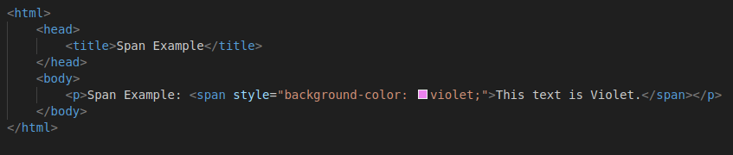

**Q15. How to insert a picture into a background image of a web page?**

**A15.** To insert an image into the background of a web page, you can use CSS to set the background image property.

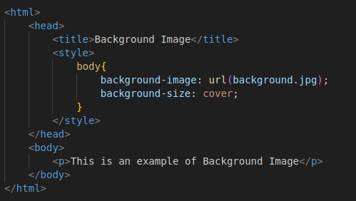

**Q16. How are active links different from normal links?**

**A16. Active links** are typically links that are currently functional and lead to live web pages, it is that line of code in action opening that other resource. An active link is typically underlined and red.

**Normal links** can refer to any link, whether functional or broken. It is just a line of code that contains a pointer to another resource. They are also known as ‘regular links’ or ‘default links’. A normal link is underlined and blue.

**Q17. What are the different tags to separate sections of text?**

**A17.** In HTML, there are several tags and elements you can use to separate and structure different sections of text within a web page. Here are some commonly used ones:

1. **<div>** - Generic container that divides content into sections.
2. **<p>** - Defines a paragraph.
3. **<h1> to <h6>** - Headings of different levels to denote section titles.
4. **<main>** - Denotes the main content of a document.
5. **<br>** - Insert a single line break.

**Q18. What is SVG?**

**A18.** SVG stands for **Scalable Vector Graphics.** SVG defines vector-based graphics in XML format. It is used to define vector based graphics for the Web. An SVG image begins with an <svg> element.

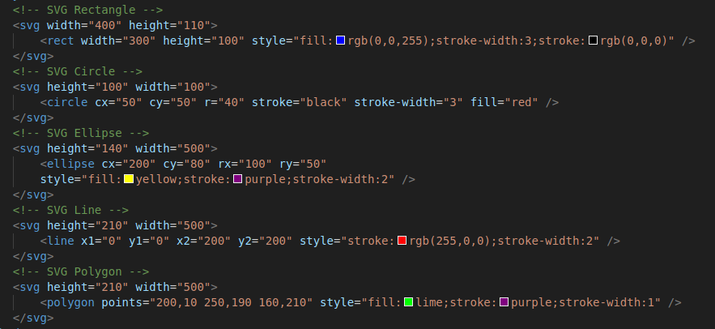

**Q19. What is difference between HTML and XHTML?**

**A19.**

| **HTML** | **XHTML** |
| --- | --- |
| HTML stands for Hypertext Markup Language. | XHTML stands for Extensible Hypertext Markup Language. |
| It was developed by Tim Berners Lee. | It was developed by W3C (World Wide Web Concortium). |
| It was developed in 1991. | It was developed in 2000. |
| It is extended from SGML. | It is extended from XML &HTML. |
| Is compatible with all browsers. | Internet Explorer 8 Browser does not support this. |
| Most compatible with mobile devices - smartphones and tablets | Better suited for desktop computers. |
| The format is a document file format. | The format is a markup language. |
| All tags and attributes are not necessarily to be in lower or upper case. | Here, every tag and attribute should be in lower case. |
| Doctype is not necessary to write at the top of the file. | Doctype is very necessary to write at the top of the file. |
| It is not necessary to close the tags in the order they are opened. | It is necessary to close the tags in the order they are opened. |
| Filename extensions used are .html, .htm. | Filename extensions used are .xhtml., .xht, .xml. |

**Q20. What are logical and physical tags in HTML?**

**A20.** In HTML, the formatting tags are divided into two categories Physical tag and Logical tag. They are used for better visibility and understanding of the text by the user on the web page.

**Physical Tags** are used to provide the actual visual appearance to the text.

Commonly used Physical Tags in HTML are **<b>**, **<i>**, **<u>**, **<sub>**, **<sup>**, etc. and attributes like **align**, **background-color**, **width**, etc.



**Logical Tags** are used to add some logical or semantic value to the text. They are used to display the text according to the logical styles.

Commonly used Logical Tags in HTML are **<abbr>**, **<address>**, **<blockquote>**, **<del>**, **<ins>**, **<pre>**, **<strong>**, **<em>**, etc.

